Food Elimination Fix Social Media Posts

Post #1

Gas, bloating, constipation can all be signs of Irritable Bowel Syndrome and be uncomfortable and a disruption to your life.
A landmark paper published in the prestigious British medical journal Gut found eliminating foods identified through delayed food allergy testing (IgG antibodies) resulted in dramatic improvements in IBS symptoms.
Do you need food elimination diet?

http://health.clevelandclinic.org/2015/09/whats-really-causing-irritable-bowel-syndrome/?utm_campaign=cc+tweets&utm_medium=social&utm_source=twitter&utm_content=150925+cause+IBS&dynid=twitter-_-cc+tweets-_-social-_-social-_-150925+cause+IBS

Post #2
What is a food sensitivity?
You are eating all the right things, lots of lean protein, plenty of organic vegetables and only sticking to the cleanest carbs like quinoa and sweet potatoes but you still aren’t losing weight and you feel lethargic all the time. So what gives? Well, along with some other things that may be going on one thing that may be an issue for you is that you are not eating the foods that are right for your body.
You may have what we call a sensitivity to some foods. This is different then an allergy to foods. When you have an allergy to a food, the food will cause a extreme reaction in the body like an anaphylactic reaction. This is what is tested for when you do a food allergy skin prick test. This is the most common test that doctors will do to test for food allergies.
However, this is not the only way your body can react to foods that they may have an allergy or sensitivity. When you eat a food that your body may not agree with it can cause inflammation inside of the body, something that you can’t see or feel and you many not have an immediate reaction.
When the body tries to digest food that it is sensitive to it can cause an adverse immune response that can end in fatigue, GI issues, weight loss resistance and chronic disease.
When eating foods that your body has a sensitivity to over and over again it starts to create a low grade chronic inflammation in your body. This can happen even when you are eating “clean foods.” If you are always eating the same foods over and over again your body can build up an intolerance to these foods causing inflammation. This is detrimental to weight loss because inflammation causes you to hold onto extra water weight in your body.

Post #3

What do brain fog, food cravings and depression all have in common?
They can be signs that something you are eating is causing inflammation in your body and you may have a food sensitivity.
How would you know? Here are 7 signs you have a food sensitivity.

http://www.prevention.com/food/food-remedies/do-you-have-food-sensitivity/

Post #4

Maria Says “My husband has spent many years suffering from unbearable back pain. It has been the a source of many arguments in our house. Of course I felt bad for him and wanted him to be happy and pain free but it was causing me so much pain too. I hated seeing him always miserable and in pain and he could never do things with me and the kids.
He was missing all of the good times we were having as a family. He was tired, cranky, miserable, no one wanted to be around him. One day I couldn't take it anymore I started to do some research and see how I could help him feel better. After a lot time trying to figure it out I came across some research saying that food sensitivities could be causing his joint pain and that a food elimination diet was the best way to reverse it.
This is when I came across Sabrina and her food elimination program. We worked together to eliminate the high inflammatory foods like dairy, wheat, soy, corn and some others, fixed up his gut with minimal supplements and within weeks his symptoms started to go away!
As the cook for the family I have started to cook with more vegetables and some of the tricks and recipes Sabrina has given me and now our family is eating healthy together. I finally have the active happy husband back that I had been missing for way too long. I am so thankful for the Food Elimination Fix."

Post #5

Think you can't have dessert on the Food Elimination Fix?
Well, you are wrong!! Here is one of the many recipes you can have on the Plan!
WHIPPED COCONUT CREAM WITH FRESH BERRIES
1 can organic full fat coconut milk, refrigerated 1/8 teaspoon vanilla extract
1/8 tsp cinnamon
1 cup mixed berries
Scoop out the thickened coconut cream from the can into a bowl. Add cinnamon and vanilla and whip the cream with a wire whisk until it begins to thicken.
Plate with mixed berries.



Post #6
Are you having fertility issues? Did you know that food sensitivities can play a part in your fertility.
Your digestive system is a major part of your immune system, our gut acts as the first line of defense against bacteria, virus and anything else that can infect our environment.
When the digestive system is challenged, by such conditions as stress, illness or food sensitivity, inflammation can result. Chronic inflammation of the digestive tract can impair our body’s ability to break down and absorb the nutrients in the food we eat.
In addition, gut inflammation may affect other organ systems, including the reproductive organs, which are in close proximity.
These factors, taken together, are why we take a very close look at digestion, and symptoms of food sensitivity, as they relate to fertility.
A Food Elimination Diet will help to remove any foods that are causing inflammation and challenging the digestive system.
Learn more about how the Food Elimination Fix can help you

https://www.fertilityauthority.com/blogger/beth-and-tami/2009/12/11/food-sensitivity-part-your-fertility-issue

Post #7

Here is an example of a snack on the Food Elimination Fix! No deprivation just making choices to try new foods!
Get all the details on the Food Elimination Fix on sale only until Friday, October 1st.(INSERT SALES LINK HERE)

APPLE CHIPS
1 apple
1 teaspoon ground cinnamon
Preheat the oven to 375 degrees.
Line a cooking sheet with parchment paper. Core an apple and slice it crossways about 1/8 of an inch thick. Place slices on a cookie sheet and sprinkle slices with cinnamon.
Bake until the apples are dry and crisp, about 30-40 mins. Cool and serve.

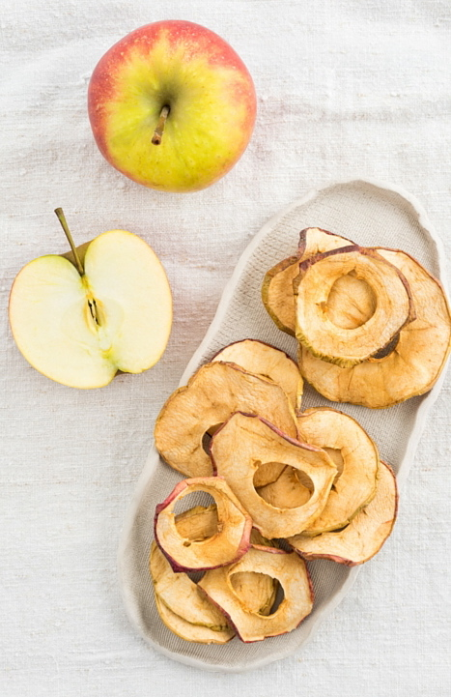
Post #8

What is the difference between pro inflammatory and anti inflammatory foods?
Pro inflammatory foods promote inflammation in the body.
Inflammation is the number one cause of disease and illness in the body.
It is important to eat foods that are low in inflammatory factors and eat foods that are anti-inflammatory.
Here is a list of foods for you to follow.
Pro-inflammatory (eat less)
Sugar
• cookies • candy • cakes
Cooking oils
• grape seed oil • cottonseed oil • safflower oil • corn oil
Trans fats- found in deep fried foods, fast foods, • partially hydrogenated oil • margarine • vegetable shortening
Dairy
milk • cheese • yogurts
Commercially raised meat
Processed meats
• ham • sausage • salami • hot dogs
Alcohol-beer, liquor, wine.
Refined Grains
• white rice • white flour • white bread • pasta • pastries
Artificial Food Additives • aspartame • MSG • color dyes
Anti-inflammatory foods help to combat disease and inflammation in the body and you should fill your diet with these foods.
Anti-Inflammatory (eat more)
Fruits and vegetables
Omega 3 filled fish
• salmon • sardines • mackerel
Nuts
• almonds • walnuts
Ginger
Turmeric
Garlic
Onions
Read more about these foods and eliminating anti inflammatory foods from your diet here: (ENTER SALES LINK HERE)



Post #9

Have you been experiencing any of the following symptoms?
-Migraines
-Headaches
-Acne
-Eczema
-Cellulite
-Joint Pain
-Gas and Bloating
-Constipation
-Fatigue
-Stubborn Weight Loss
Did you know that a food intolerance could be causing these issues and there is a solution for you.
It is called the Food Elimination Fix!
This step by step program makes it easy and manageable to remove any foods that could be causing your symptoms.
See more about the program here: (INSERT SALES LINK HERE)



Post #10
Confused about Gluten?
Mark Hyman, MD breaks it down for us.
Think you may have a gluten allergy and want to learn how to remove it out of your diet?
Only a few more hours left to grab your copy of the Food Elimination Fix don't miss out! Get it here: (INSERT SALES LINK)

http://www.doctoroz.com/episode/sorting-through-misinformation-gluten?video_id=4501034012001

Post #11
{New Blog} Do you feel like you have tried every diet and still can't lose weight?
Could something like a food sensitivity be holding you back from losing weight?
In my most recent blog I discuss the reasons food intolerance may be causing your weight gain or stubborn weight loss and how to solve it.
Read more: http://www.sabrinasarabella.com/blog/the-missing-link-to-your-weight-loss



Post #12

When Anna first came to me she was always tired, took an antidepressant and a pill for acid reflux. She said was tired of feeling tired all the time and having stomach issues. Anna and I worked together to change up her diet and remove gluten and dairy. Within weeks of removing these things from her diet she started to feel better. Her major struggle was she was always out entertaining for work and every day was eating at a different restaurant. At first she found it very difficult to go out and avoid things like pasta and pizza, her favorite foods! After working together to find alternatives to her favorite foods she started to enjoy going out to eat and not dread it anymore because she was not prepared and knew what to order.
"I did not want to cut gluten an dairy out of my diet when Sabrina first suggested it, it didn't fit my lifestyle and I didn't know how I would survive. Two years later and now I have no idea how I survived through years of stomach issues and extreme fatigue. I have learned to make new food choices that I know will not upset or hurt my stomach. I am so happy that I decided to take control of my health! The food elimination fix was key to me regaining my health." -Anna
Food Elimination Fix on sale until...(ENTER SALES LINK HERE)

Post #13

Have you been experiencing any of the following symptoms?
- Gas/bloating
- Acne/complexion issues
- Brain fog, mental sluggishness
- IBS or constipation
- Migraines/head aches
-Fatigue
- Nutritional insufficiency/absorption issues (check hair/nails, for example)
- Weight loss resistance or unexplained changes in weight, etc.
A common cause of these symptoms can be food intolerances and a food elimination diet can help to relieve these issues and heal your gut.
My 6 week step by step guide on how to remove foods that may be causing inflammation in your body and causing pain and discomfort is on sale for only one more day.
Check out the full details of the Food Elimination Fix here: (ENTER SALES LINK HERE)



Post #14

When you have a food sensitivity you can feel left out since you can't eat the same foods others can. However, there are always alternatives foods that you can eat.
In the Food Elimination Fix you will get a step by step guide on how to remove foods you may be sensitive to out of your diet.
A key part of an elimination diet is to find new foods that can replace old favorites. Such as spaghetti squash or zoodles instead of pasta. Or paleo oatmeal instead of regular cereal.
Only one more day to get the Food Elimination Fix and start living pain and symptom free.(enter sales link here)



Post #15

What's for breakfast on the Food Elimination Fix?
Paleo Oatmeal!!!
PALEO OATMEAL
1 1/2 cup applesauce, unsweetened
4 tablespoons almond butter, raw, chunky
2 tablespoons coconut milk, full fat, unsweetened canned 1 teaspoon cinnamon to taste
1 teaspoon nutmeg, fresh, grated
Combine all ingredients in a small pan over medium heat, stirring until all is combined and warm. Add fresh or dried fruits or nuts for additional texture and flavor.
So many great recipes on the Food Elimination Fix!
Check it out here: (ENTER SALES LINK HERE)

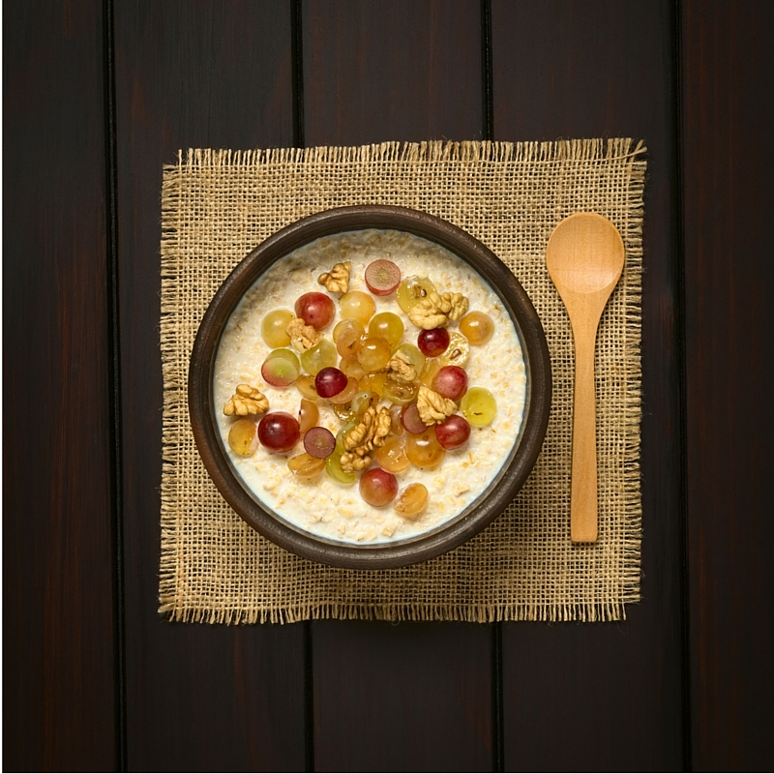

Post #16

Linda says:
"I was having CRAZY symptoms
* fatigue * crankiness * social anxiety * jitters throughout my body and the worse was little zaps in my head. I thought I had a brain timer or something like that going on in my head.
After doing an elimination diet I felt better then I had in years. Let me just tell you it was not easy especially the first couple of weeks.
I had to eliminated gluten, dairy, whey, wheat, soy, eggs, coffee, chocolate and alcohol for 12 weeks. Literally everything I ate!
Let me tell you, you get very creative and you enjoy new foods that you have never had before. The motivation was to feel better, I NEVER want to feel that way again and ya know, you find new favorite foods.
smile emoticon
Pros to an elimination diet.
* you feel great
* you look great, no more dark circles under your eyes, no more brittle nails and hair, etc..
* weight loss
* no more mood swings
* sleep better
* the list goes on
Cons to an elimination diet
* you miss your favorite foods
* it's hard to eat out especially when your with friends
* you have to read labels
Bottom line doing the elimination diet gave me my life back. Like I said I feel amazing and that is worth it. Remember it is not forever, after the 12 weeks I started adding foods back in and some foods I can enjoy again with no issues but some I would rather keep out! I'm excited for you to try it and reap all the positive benefits, I promise you will not regret it!!"
Ready to start your elimination diet? I made it super easy for you by designing my Food Elimination Fix. Get all the info here: (ENTER SALES LINK HERE)

